RADIO – NEWS 1

What is news? (see separate sheet)

Elements to keep in mind while gathering and writing news:
- news judgment
  - determine what is news
  - select details pertinent to the story
- accuracy
- balance
- clarity
- verification of facts
- objective focus

Elements to keep in mind specifically for radio news:
- listener only hears the story once
  - be clear
    - in writing
    - in voice
- identify the 5Ws and H
- summarize key facts
  - radio news does not always have time to report “why”
  - active voice often leads to the “who” of the story coming first
- include actualities (sound quotes) and attribute them
  - attribution comes first in radio
- decide what is most essential news for the audience
- bring the listener to the scene of the story using descriptive writing and sound
- most stories will be 20 seconds or less (40 words) so use words wisely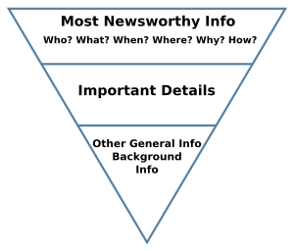
ASSIGNMENT – 1-minute newscast

-Find five news stories on the internet
-Rewrite the stories to radio style
- Type and print in proper script style (each story on its own page)
-Rank the stories as you think they should be read
-Script, type and print an intro and outro to your newscast, using
“W-P-P-B, The Pulse” as the name of the station
-Record, using at least three stories, but not going over the 1-minute limit

