JOURNAL #9 – READ THE ARTICLE AND ANSWER THE QUESTIONS AT THE END
Device Uncovers the Secret Things You Do in Your Sleep

September 10, 2012 by InnovationNewsDaily 1

InnovationNewsDaily

Like 47k
Follow @news_innovation 2,753 followers

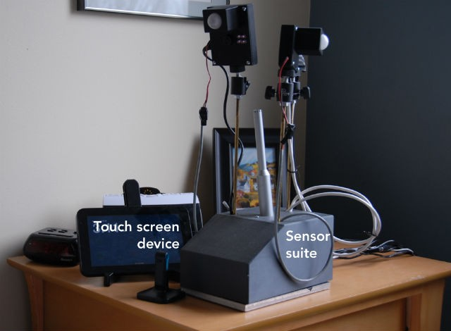

Matt Kay had been sleeping with a Lullaby device on a nightstand when he noticed that his Lullaby data showed a noise had awakened him around 8 a.m. Curious, he tapped the touchscreen to see what the infrared photos recorded in his sleep.

“It was actually a telemarketer calling me. I woke up and hung up on them. I’d totally forgotten about it until I saw the video,” Kay told InnovationNewsDaily. “There’s something really interesting about using a system that’s sort
of exposing this unconscious experience for you.”

Kay is a doctoral student in computer science at the University of Washington, where he’s been developing Lullaby, a table lamp-size device meant to put a sleep lab in people’s bedrooms. The idea for the system came from talking with sleep scientists, he said.

SEE ALSO: People Can Learn While They’re Asleep, Study Finds (InnovationNewsDaily)

“When a lot of people have sleep problems, they’ll go into a clinical sleep center, where they can, fairly

accurately, assess the quality of your sleep,” he explained. “The problem is they can’t really identify things that are going on in your home that might be causing you to have sleep problems.”

The device is still far from being marketed, but Kay said he and his colleagues — sleep scientists and computer scientists at the University of Washington — imagine people could use Lullaby to figure out how to improve their sleep on their own, or to record data for sleep doctors to make diagnoses.

A Photo Every 15 Seconds

The new device tracks users’ sleep quality along with light, sound and temperature. An infrared sensor detects motion throughout the room, while an infrared camera snaps pictures of the sleeper herself every 15 seconds.

Users are able to stop the audio and image recording any time they like. They can also delete 15-minute chunks of the recording after the fact, snuffing out records of sexual activity, clothes changing or nose-picking.

The next morning, users are able to pull up graphs of the recorded data to see if, for example, Kitty’s nocturnal wanderings are associated with bumps of restless sleep. The data visualizations highlight times when conditions weren’t ideal — when the room was too hot or too cold, for instance, or when there was a spike in noise. Tapping on the sound graph replays the noises Lullaby recorded for that period of time, allowing users to try to identify spikes. Users are also able to see images of themselves from any time.

To see if people outside the lab liked the design of Lullaby, Kay and his team tested their device with four people they found on Craigslist. Each of the study volunteers slept with Lullaby by their beds for 14 nights, the standard amount of time doctors use to diagnose sleep disruptions.

The researchers found people were generally curious about their sleep. “It was fun to go through the data in the morning, and I kept on trying to find myself snoring,” one of the testers told Kay and his team.

One study volunteer using Lullaby data found she coughed frequently in the night, which is one symptom of sleep apnea. She also found her bedroom was too hot sometimes, so she started sleeping with a fan. That showed a limitation of the device’s sensors, as the fan only made the volunteer feel cooler, without affecting the room’s temperature and thus the device’s recordings.

There was also a limit to how much users could figure out from the Lullaby app. They could see the graphs for only one night; they couldn’t easily see patterns over days or weeks. So the researchers crunched some
long-term numbers for their volunteers, finding there was a weak association with temperature and waking up in the night for one of the volunteers, for example.

SEE ALSO: U.S. Health Agencies Want Device to Track People Breathing (InnovationNewsDaily)

Cost and Future Plans

The sensor suite, which was made entirely from commercially available components, cost about $100, Kay estimated. Researchers also had to pay for tablets to show the data and a small computer to store the data, but a commercial version may hook up to users’ own smartphones and computers, for a cheaper product, he said.

The commercial future of Lullaby is uncertain, however. Its creators are “exploring possible opportunities for commercialization,” Julie Kientz, a University of Washington computer scientist and Kay’s adviser, wrote to

InnovationNewsDaily in an email. “Right now there aren’t immediate plans to commercialize Lullaby, but it’s certainly not off the table.”

Kientz, Kay and their colleagues still have plenty of ideas for improving Lullaby. One is to give Lullaby the ability to do analysis on its own, so that the device can offer one-sentence summaries to people such as, “Over the past two weeks, higher temperature has been associated with worse sleep.”

Next-generation Lullaby devices might come up with personalized temperature and noise recommendations, based on observing their owners. Lullaby’s creators may also turn it more into a lab device that doctors loan to their patients. For that application, researcher will need to test Lullaby in the randomized controlled trials required for medical devices.

The researchers presented their latest Lullaby work on Sept. 6 at UbiComp, an Association for Computing
Machinery-hosted conference held this year in Pittsburgh, where they won a best paper award.

Putting the Science into Forensic Science Study to Develop Policies for Police Drones Computer Program Identifies Rough Sketches Microwave Weapons Under Scrutiny

This article originally published at InnovationNewsDaily here.

Follow InnovationNewsDaily

InnovationNewsDaily is a Mashable publishing partner that reports on futuristic technologies, innovations, disruptive ideas and cool gadgets that will shape the future, and explain why it all matters and how it will affect your life. This article is reprinted with the publisher's permission.

WRITE A PARAGRAPH CONTAINING THE ANSWERS TO THE FOLLOWING QUESTIONS:
What do you think about this device?
How can the info gathered from it help improve sleep?
Describe how poor sleep can be both a health problem and a safety problem.
Would you volunteer to use the machine?
What do you think it would find about what you do in your sleep?
Have you ever had someone tell you something you did in your sleep that you had no idea happened?
Tell of some of the weird things that have happened to you or that you have done while sleeping. If you don’t know of any concerning you, tell of a family member or friend’s experience.

