Back to school: More public schools require uniforms
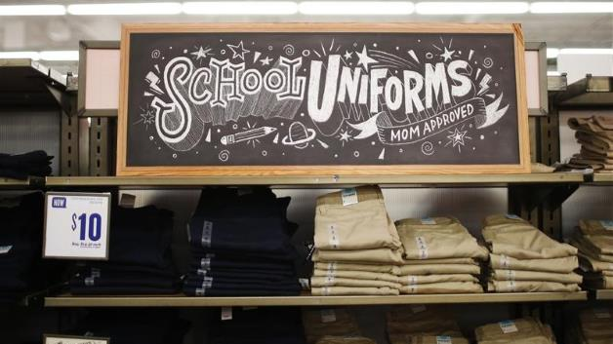Reuters
Back-to-school spending is expected to fall 8 percent this year, due in part to more public schools requiring uniforms.
8/15/13 By Dhanya Skariachan of Reuters

SHARE
21

TWEET

EMAIL

While some students oppose school uniforms, many school principals are advocating a uniform policy citing its positive impact in schools — public and private.
NEW YORK — A growing number of school children will be required to wear a uniform this school year. The trend is expected to gain steam as public school enrollment continues to set new records.
That has boosted prospects for uniform sales in the United States and made the category one of the few bright spots this back-to-school season when the National Retail Federation expects overall spending to fall 8 percent.
Uniforms were once required mostly by U.S. private and parochial schools. More public schools have begun to require them. Many school principals are advocating a uniform policy citing its positive impact on issues like peer pressure, classroom discipline, student safety and bullying.
Almost half of U.S. public schools now have a formal dress code or uniforms compared with 21 percent in 2000, according to a survey by Lands' End and the National Association of Elementary School Principals. At the same time, more private schools are requiring uniforms with their logos, said John Maher, senior vice president at Lands' End Outfitters.
Related: Have you ordered your bulletproof school uniform yet?
Though still just a tiny piece of the close to $27 billion dollar back-to-school market, retailers such as Wal-Mart, Target, Lands' End, Old Navy and Staples are eager to compete for uniform sales and the additional traffic they bring to stores and websites during the second biggest selling season of the year.
"All our retailers are projecting increases for this year," said Michael Arking, president of FrenchToast.com, which has more than 10 percent of the U.S. uniform market. He expects sales to rise 10 percent this year. He said about 100,000 students will wear uniforms for the first time this fall.
In the 2013-2014 school year, over 100 public school districts, representing 650,000 students, are considering or implementing a school uniform policy, a 25 percent increase over 2012, according to an annual school survey by French Toast and research firm Morley.
Over the years, the definition of uniforms has changed.
"Essentially it's not so much you know plaids and ties and sports jackets. It is a lot more casual polos and khakis and basics," Arking said.
French Toast, owned by the LT Apparel Group, expects to double its share of the highly fragmented $930 million U.S. uniform market in five years. Other prominent U.S. uniform suppliers include Elder Manufacturing Co, School Apparel, Dennis Uniform, Rifle/Kaynee, Flynn & O'Hara Uniforms and Young Fashions School Uniforms. They are all privately held.
LOOKING TO IMPRESS
Sensing their opportunity, retailers are stepping up competition in the uniform aisles and online.
Walmart has set up "uniform shops" or temporary boutiques within some stores rather than just displaying uniforms in the apparel section. It has added uniforms this year to "Classrooms by Walmart," an online tool for parents and teachers to access school supply lists from thousands of schools.
Target, which carries uniforms in 800 of its 1,700 stores, said uniform sales so far are "strong." It is seeing a "particular uptick" in online sales. Target has for the first time "created a uniform destination" in about half of its stores that carry them, spokesman Joshua Thomas said, adding it was too early to comment on the sales impact from the initiative.
Lands' End said its "single largest day" of uniform sales ever in July this year.
Related: District microchips uniforms so students don't skip school
"Our back-to-school business has started extremely strong," said Edgar Huber, CEO of Lands' End, a unit of Sears. While about 1.5 million students currently wear Lands' End uniforms, he sees it rising to 5 million over two years.
Even stores that have not sold uniforms before are jumping on the bandwagon. Staples, known more for paper and printers, is carrying uniforms for the first time ever, albeit online.
"As we're seeing more and more public schools going to a uniforms model, this category is a natural choice for Staples for back to school, as we provide a one stop shopping experience," said Christine Mallon, vice president of marketing strategy and customer segments at Staples.

WHAT’S YOUR VIEW ON THE PROS AND CONS OF SCHOOL UNIFORMS? WHAT WOULD BE YOUR DRESS CODE POLICY? Write a 5-7 sentence paragraph on the issue.

