JOURNAL 35

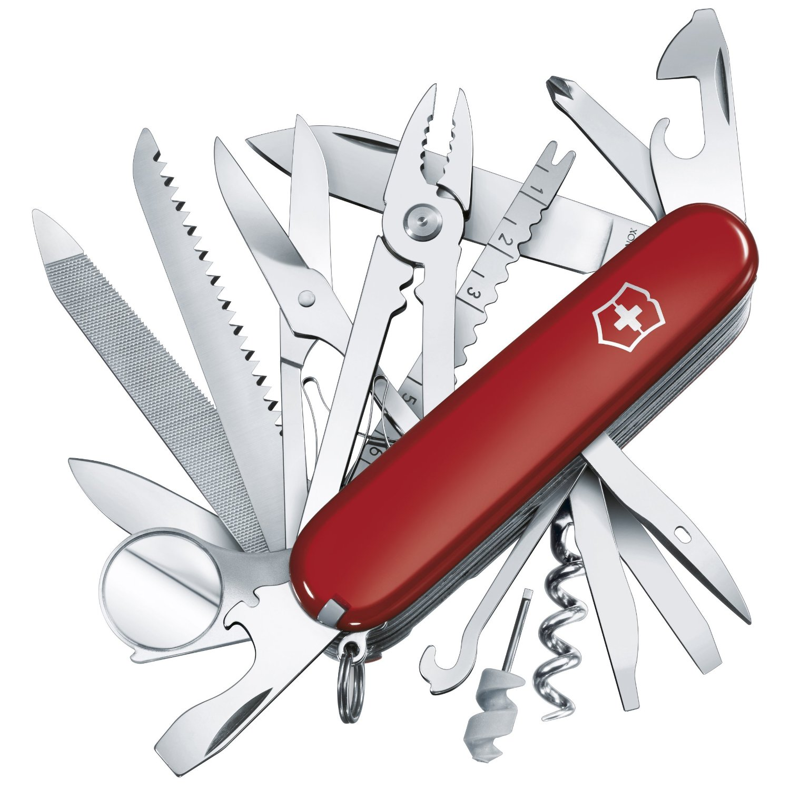
Many of us are familiar with the Swiss Army Knife, that clever gadget that houses somewhere around 276 tools in one handy red plastic sheath. You may never have a glaring need for a 2-inch hacksaw, but there are things that we use every day that might make more useful tools.

Your task is to invent your own Swiss Army Thing. What would your sheathed utility tool hold? List at least 10 items it would have to help you survive in your personal world.

