JOURNAL 34

Paul Walker death shatters 'Fast and Furious' car fantasy
By James Hibberd on Dec 5, 2013 at 5:04PM @james_hibberd
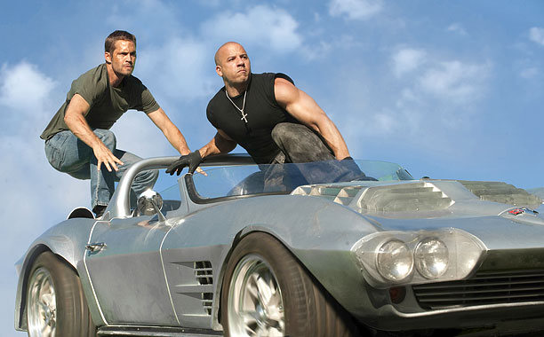
I saw a weird screening of Fast Five at Austin’s Alamo Drafthouse Cinema last month, featuring a comedy troupe called Master Pancake who sit in the theater’s front row and mock the film — it’s basically like Mystery Science Theater 3000 performed live. The comics ripped Vin Diesel’s grunty performance, the crazily implausibly stunts, the gaping plot holes. Yet even after the film was comically eviscerated, I knew none of the quips and critiques would diminish my future enjoyment of watching the Fast & Furious franchise.
But you know what does diminish it? Utterly destroys it, actually?
Paul Walker dying in an absolutely horrific car crash.
Because it’s so awful. Because it’s so tragic and ironic. Because he was in a car — a muscled-out Porsche, not entirely unlike the high-performance luxury cars in the films. Because he wasn’t even killed on impact, like we silently hoped when hearing the news. The initial autopsy report says Walker was still alive when the vehicle became engulfed in flames.
And such fatalities are what happens, sometimes, when cars crash. More than 35,000 people in the U.S. die each year in car accidents.
The Fast & Furious franchise took an old-fashioned cinema action beat — the car chase — and created a flashy customized super-charged monster version of the trope: Illegal racing, Nitro boosts, insane speeds, empty streets, near misses, epic stunts. Lots of incredibly risky-looking driving, and our heroes almost always walk away unscathed. At one point during the Fast Five screening, the mockers noted that an over-the-top wall-busting fist-fight between The Rock and Vin Diesel resulted in neither character having a mark on them. That’s the brand. The F&F heroes can do just about anything, particularly behind the wheel of a car, and all will be okay.
As action-fantasy, that’s cool. It wasn’t wrong to make it. It’s not wrong to like it.
With Walker’s death, production has halted on Fast 7. The studio is wisely trying to figure out what is the best and most sensitive course to take. Roughly half of the film has apparently been shot. Meanwhile investigators are trying to determine if Walker’s friend at the wheel, Roger Rodas, may have been driving too fast. Another area of speculation is whether the accident might have been caused by something as mundane as a mechanical problem, such as a blown tire — one of those real-life potentially fatal issues that plague real-life cars.
Regardless of exactly how the accident happened, here’s the question: Can you watch Fast & Furious racing, the core action in this six-films-and-counting franchise, and still enjoy it the same way as before — as a deliriously goofy thrill ride? Can you watch Walker’s now-shattered friends and co-stars racing cars, and especially Walker himself, without being haunted by thoughts of his final moments and his friends’ grief? In other words: Does the way an artist died influence how you process his art? Especially when it’s an actor who made car racing fantasies and he dies in a fiery crash? Or is the manner of Walker’s demise irrelevant?
Some will easily brush all this off. Millions watch real-life auto racing, which sometimes claims the lives of its drivers, and still enjoy the sport just as much as before. And there were plenty of people on Twitter outraging Walker’s fans by caustically joking about his death after the news broke. So sure, many will watch the Fast crew get in their cars, gun their engines, floor the pedal and feel just … fine.
I won’t, though. And I suspect there’s a few others won’t find the same thrill in the films again either. Is that normal, or over-sensitive? It’s not like the films were misguided to embrace a high-speed vehicular fantasy, but it’s like being at a party where there’s a tragic accident — the party wasn’t wrong, yet feels over just the same; the fun has been ripped out of it. A Hollywood comparison that’s frequently being made to this tragedy is Heath Ledger dying right after The Dark Knight wrapped, but that’s a poor one. Ledger’s death wasn’t such an eerie ironic echo of the film’s creative content. Walker’s death is like … Aquaman drowning. Superman falling off a cliff. It’s beyond irony. It’s too close.
Write a paragraph stating your opinion on this issue, how you agree or disagree with the author’s position, and answering any questions brought up in the article.

