How Students Used Social Media To Help Others In Need

7
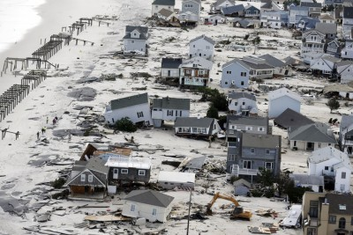

Mike Groll/AP – This aerial photo shows destruction in the wake of Superstorm Sandy on Wednesday in Seaside Heights, N.J.

Students care. When they care and mobilize, the world changes around them.

Students at the William M. Davies Career & Technical High School in Lincoln, Rhode Island discovered that Hurricane Sandy had severely affected family members of one teacher, whose sister in law was from Brick, New Jersey.

They jumped right in, using social media to mobilize and create awareness of the extent of the damage and to lend a helping hand. Many of these students had not been directly affected by this storm but remembered the effects of the East Coast flood two years earlier.

It Started With One Tweet

“It started with one tweet,” said Skills USA Student Government Treasurer Austin Moore, “and you responded.” Moore’s speech to students, faculty, staff, and administration recounted how while at a Skills USA leadership conference, Skills USA advisor and Social Studies/English teacher Kristin St. Pierre happened to mention that her sister in law’s town had been badly affected by the storm and was a long way from recovering. She “sent one tweet” to that effect, said Moore, “and over the weekend it went viral. “

“You retweeted this message. You got the message out,” he told students. In the end, thousands of items were donated by students, faculty, staff, administration, local and out of state
churches and by other schools throughout Rhode Island.

Skills USA Student Government President Blessing Gbemisola’s message thanked the school for coming together as a family. She stated how this experience had rallied the Davies

community, and that any family member of a member of the Davies community was “part of the Davies family, too.”

St. Pierre and her family will be transporting this material to New Jersey over the Thanksgiving holiday. St. Pierre serves as co-advisor, along with graphics instructor Joe Fantozzi, to the Davies chapter of Skills USA. Skills USA is a national organization which partners students, teachers, and industry leaders to develop and ensure that America retains a strong technical workforce. It sponsors leadership conferences, events, and competitions throughout the United States. The Davies chapter has always been strong, routinely taking home state victories in several technical area competitions and placing strongly on the national level in the annual national Skills USA competition held in Kansas City, Kansas.

This point, though, is significant. Strong leadership development combined with social media mobilizes students. Students are able to see a need and rally the troops around that need quickly and powerfully.

Power of the Student

Too often we, as educators, fail to recognize or harness the power of the student. When students are given control, they are able to do great things.

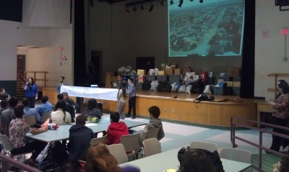“People stepped up to our calls for action,”
said Skills USA Student Government Vice President Wesley De La Rosa. “Companies and organizations stepped up. One parent of a former student donated 300 toothbrushes. Friends of the Smithfield Public Library donated hundreds of books.” De La Rosa’s rallying speech credited dozens of members of the community and the greater state for assisting with this cause.

Skills USA Student Government Secretary Claudia Braz mentioned that Vice Principal Jerry
Manning’s mother knitted seventy hats and pairs of gloves.

This drive was a success not just in helping a ravished community get some needed supplies. It showed the leadership power of the Skills USA National program on a very local level, and it showed the power of social media in quickly organizing such an effort on a larger scale.

A Bigger Result

That would have been significant in and of itself. This drive accomplished much more than that, however. The William Davies Career & Technical High School is a regional school, pulling

from several towns and cities in northern Rhode Island. Unlike a neighborhood school, students often spend a significantly longer time on buses to get to school. They often require transportation to attend school functions like dances, rallies, and sporting events. This makes it much more of a challenge to form that sense of community that neighborhood and community schools take for granted.

These students exhibited several powerful examples of student leadership. They proved how students, given the authority and power to do so, will rise up and own any challenge or cause in their path, and when empowered to do so, they will surpass the greatest expectations of the adults in the room. They also showed how technology and social media–given the proper
venue, can help build and strengthen communities.

The William M. Davies student leadership started this journey to help people in need, but what they found is they helped themselves and their school community in the process.

- What were the keys to this student endeavor that made it work?
- In case of a community emergency in our area, how would you mobilize such a student effort?
- Without a community emergency, what common causes could be helped by such a student effort? Put together a step-by-step procedure that could be followed to get something going. Be specific about what causes could be helped.
- What is the biggest thing needed by students and leadership to make such efforts take place.

