Journal 26

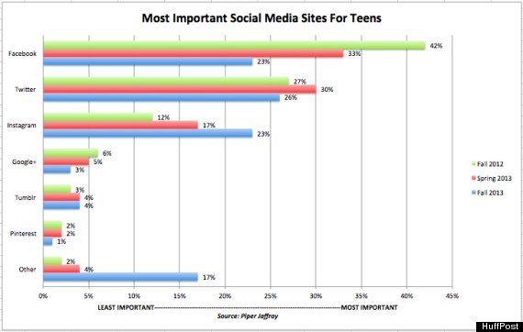

Using the information in the graph above, summarize what the results mean for the direction of teen social media use. Give your ideas for the reasons for the rise or decline of certain sites, which sites you think are fads, what sites you use the most, and which one (listed or not) you think will be the next big thing. If you do not use social media, provide your analysis anyway and include reasons why you don’t use social media or what sites you would like to use.

