The Science Of Cool | Co.Design | business + design http://www.fastcodesign.com/3032932/evidence/the-science-of...

READ THIS ARTICLE, FOLLOW THE INSTRUCTIONS AT THE END, AND SUBMIT IT

EVIDENCE The Science Of Cool

WHAT MAKES ONE CONSUMER DESIGN COOL AND NOT
ANOTHER?

Take a look at the two water bottles below. The one on the left is pretty much your standard water bottle design: tall, clear, probably crinkly. The one on the right feels a
bit less conventional, with its sleek aluminum shell shaped like an Erlenmeyer flask. In a survey of which is cooler, the bottle on the right would win right away, though both bottles serve the very same function.

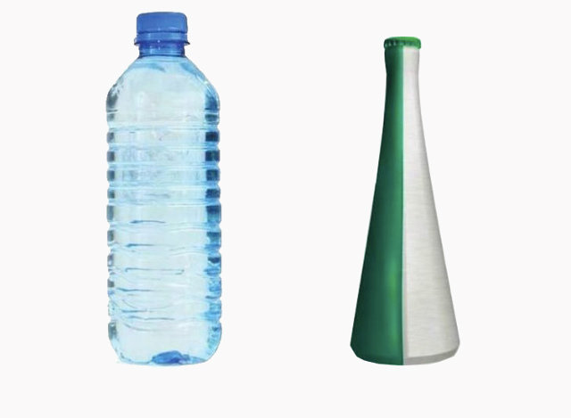
Journal of Consumer Research

So what is it, exactly, that makes one design cooler than another? The difference is surprisingly tough to articulate. You might say it's because the bottle on the right is unconventional. But a water bottle shaped like a kangaroo would be unconventional, too, and you wouldn't necessarily consider it cool. There's more to it
than just being different.

1 of 10 8/28/14, 11:52 PM
“BEING COOL REQUIRES
A lot more, actually. Behavioral
The SciencAe OVfECRooYl |DCEo.LDIeCsiAgnTE| business + desigsncientists have spilled hqttup:it//ewwa wb.iftasotcfodesign.com/3032932/evidence/the-science-of...
empirical ink on what makes
BALANCE OF DOING SOMETHING THAT
SHOWS THAT YOU GO YOUR OWN WAY, BUT
YOU DO IT IN A WAY THAT IS SOCIALLY
ACCEPTABLE.”

something cool. They've basically whittled the phenomenon down to four main traits.

First, cool is a social perception, not an inherent quality. So, Pabst Blue Ribbon (PBR) has always been PBR, but it wasn't cool until Portland hipsters embraced it. Second, coolness is relative. One shirt from Walmart might seem cool compared
with another shirt from Walmart, but neither will be as cool as a shirt from H&M (which itself might seem less cool than another H&M shirt). Third, coolness is almost universally positive. And fourth, something that's cool tends to diverge from the norm.

“BEING
It's this fourth trait--the unconventionality of cool--that seems to be the key. But in the past that trait been poorly defined. As shown by our example of the kangaroo water bottle, or even a real life product
like a Segway, being
unconventional alone is not enough to be cool. And, in fact, designs or brands that diverge from the norm too much run the risk of being not just uncool but strongly disliked.

Recently, marketing scholars Caleb
Warren and Margaret C. Campbell

2 of 10
UNCONVENTIONAL
ALONE IS NOT ENOUGH

tried to understand the connection between conventionality and coolness with a bit more precision.

8/28/14, 11:52 PM
The SciencTe OOfBCEooCl |OCOo.DLe.”sign | business + desigTnhey did so through ahsttep:r/i/ewswowf.fassixtcodesign.com/3032932/evidence/the-science-of...
experiments comparing consumer
products (like the bottles above), coolness ratings (the bottle on the right does rate
higher), and participant reactions. In the end, Warren and Campbell concluded that cool designs tend to be "appropriately" unconventional--that is, they challenge unnecessary norms, and aren't too extreme themselves.

"Being cool requires a very delicate balance of doing something that shows that you go your own way and do your own thing, but you do it in a way that is socially desirable or at least acceptable," Warren tells Co.Design.

In their most telling experiment, the researchers introduced test participants to four fictional fashion brands. Each brand was paired with a description that aligned it with a low, moderate, high, or extreme level of unconventionality. A "low" level of unconventionality
was essentially the norm--something that followed the market. A "moderate" brand often conformed to convention, while a "high" brand often defied convention. Extreme brands were controversial.

Warren and Campbell found the highest coolness ratings among the brands in the middle: not too conventional, not too risky. A moderately unconventional brand was cooler than a typical brand; a highly unconventional brand was cooler than an extreme and controversial brand. This pattern mostly held true whether the raters (i.e., test participants) had countercultural personalities
or not. In other words, even people who challenge convention as a lifestyle don't always think extreme
unconventionality is cool.

3 of 10 8/28/14, 11:52 PM
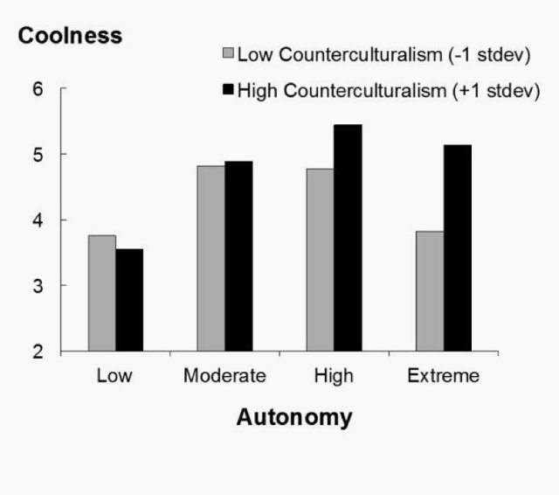
The Science Of Cool | Co.Design | business + design http://www.fastcodesign.com/3032932/evidence/the-science-of...

The researchers use the term "autonomy" instead of "unconventional."
Journal of Consumer Research

The lesson for designers is they need to know two things about an audience to make a product cool. First, what does that audience consider normal? (The design can fit slightly outside that mold.) Second, what does that audience consider the limits of abnormality. (The design should not cross it.) In the context of our water bottle designs, then, "Erlenmeyer flask-ish" rests beyond "clear and crinkly" but still within "kangaroo-shaped." (The unconventional water bottle is actually a Heineken
design.)

“TOO MUCH COOLNESS CAN BE A BAD THING IN THE LONG RUN.”

onto."
"Product designers, the good ones, know a lot of this implicitly," Warren says. "I think most of them are trying to be different or create things that are different in a way that's still accessible, or that people can latch

4 of 10
The perpetual concern for consumer designers, in particular, is that too much coolness can be a bad thing in the long run. A design that starts off as cool shifts the lines of conventionality, and then gets imitated so much

8/28/14, 11:52 PM
The Science Of Cool | Co.tDheastigint |bbeucsionemsse+sdceosignnventional, at which pohtitnp:t//iwt wcwan.fa'tstbcoedesign.com/3032932/evidence/the-science-of...
cool by definition. It's the sort of classic mainstream backlash that keeps one-time consumer iconoclasts, such as Apple or Google, searching for ways to remain outliers.

"If you're really doing something right, the chances are the coolness isn't going to last," Warren says. "Because you're going to shift what is the norm."

[Image: Pabst Blue Ribbon via Flickr user Mark Faviell]

ERIC JAFFE

Eric Jaffe writes about cities, history, and behavioral science. Continued

Twitter

Write a good paragraph (right here) about what you learned about “cool” from this article.
Do you agree with the article?
Did it enlighten you?
Did it change or solidify your opinion?
What is your definition of cool?
Is cool a good or bad thing? Why?
Who is responsible for creating cool? Will that ever change?

