TEENS
How Texting and IMing Helps Introverted Teens
Digital communication may seem impersonal, but that distance may also provide some benefits, especially for troubled teens

By MAIA SZALAVITZ | @maiasz | August 30, 2012 | 8

Log In with Facebook Sharing TIME stories with friends is easier than ever. Add TIME
to your Timeline.

Learn More

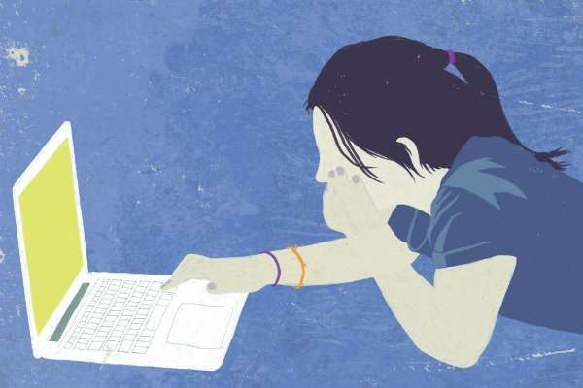
DON BISHOP / GETTY IMAGES

There is plenty of grumbling about how social media — texting in particular — may be harming children’s social and intellectual development. But a new study suggests that constant IM’ing and texting among teens may also provide benefits, particularly for those who are introverted.

Israeli researchers studied instant messages exchanged by 231 teens, aged 14 to 18. All of the participants were “regular” or “extensive” IM’ers. In the U.S., two thirds of teens use instant messaging services regularly, with a full third messaging at least once every day.

The researchers analyzed 150 conversations in the study, and reported the results in the journal Computers in Human Behavior. In 100 of these chats, the study participant began IM’ing while in a negative emotional state such as sadness, distress or anger. The rest were conversations begun when the participant was feeling good or neutral. After the chat, participants reported about a 20% reduction in their distress— not enough to completely eliminate it, but enough to leave them feeling better than they had before reaching out.

“Our findings suggest that IM’ing between distressed adolescents and their peers may provide emotional relief and consequently contribute to [their] well-being,” the authors write, noting that prior research has shown that people assigned to talk to a stranger either in real life or online improved their mood in both settings, but even more with IM. And people who talk with their real-life friends online also report feeling closer to them than those who just communicate face-to-face, implying a strengthening of their bond.

(MORE: Does the Internet Really Make Everyone Crazy?)

Why would digital communication trump human contact? The reasons are complex, but may have something to do with the fact that users can control expression of sadness and other emotions via IM without revealing emotional elements like tears that some may perceive as embarrassing or sources of discomfort. Studies also show that the anonymity of writing on a

device blankets the users in a sense of safety that may prompt people to feel more comfortable in sharing and discussing their deepest and most authentic feelings. Prior research has shown that expressive writing itself can “vent” emotions and provide a sense of relief— and doing so knowing that your words are reaching a sympathetic friend may provide even more comfort and potentially be therapeutic.

Researchers also found that introverted participants reported more relief from IM conversations when they were distressed than extraverts did. As Susan Cain, author of Quiet: The Power of Introverts in a World that Can’t Stop Talking, wrote recently for TIME:

Introverts are often brimming with thoughts and care deeply for their friends, family and colleagues. But even the most socially skilled introverts (of whom there are many) sometimes long for a free pass from socializing en masse or talking on the phone. This is what the Internet offers: the chance to connect — but in measured doses and from behind a screen…

[W]hen you’re blogging or tweeting, you don’t have to wade through small talk before you get to main point. You have time to think before you speak. You can connect, one mind with another, freed from the distractions of social cues and pleasantries — just the way readers and writers have done for centuries.

(MORE: Why Gadgets Are Great for Introverts)

For teens who are just learning to negotiate a changing social world and establish new relationships, IMing may provide just the outlet they need for sharing feelings and connecting with peers without the embarrassment of exposed emotions. For parents, however, it’s worth remembering that the comfort comes with dangers as well, since online predators are eager to exploit this openness and prey on young texters’ vulnerability. Monitoring the friends and contacts the youngest teens are connecting with online can minimize the threat; as with any service, it’s a matter of balancing the benefits with the risks.

Maia Szalavitz is a health writer at TIME.com. Find her on Twitter at @maiasz. You can also continue the discussion on
TIME Healthland’s Facebook page and on Twitter at @TIMEHealthland.

- What is your opinion of this article and the study it talks about?
- How does it say that texting can help in emotional situations?
- Do you think texting can be better than human contact in some situations? Why or why not?
- After reading this article, what do you think are the positives and negatives of texting?
- Does texting relieve stress for you?

