READ THE ARTICLE AND ANSWER THE QUESTIONS AT THE END IN PARAGRAPH FORM.

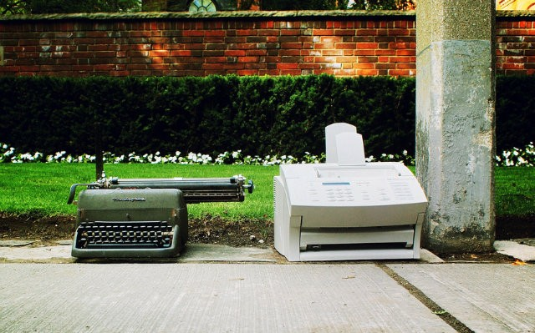
10 Office Technologies on Their Way Out

September 25, 2012 by Seth Fiegerman 32

Here’s a question you may not hear at all in 2017: “Did you get my fax?”

LinkedIn surveyed more than 7,000 global professionals about which tools and trends will disappear from offices in the next five years and which will become even more common. Nearly three quarters of those surveyed said they expected fax machines to disappear, making it the second most likely office technology to go extinct behind tape recorders.

Other once common office tools like the Rolodex, desk phones and even desktop computers ranked high on the list of items likely to become obsolete in the workplace. Meanwhile, more than half of professionals surveyed (55%) believe that tablets will become increasingly common in the office, the most of any technology on the list. Laptops also ranked high, with 34% of those surveyed predicting it would become more common.

The survey is just the latest example that workplaces are gradually abandoning analog technologies for digital. Those in the workforce will need to adapt to these changes or else risk having technological skills that are obsolete as well.

While it’s unlikely many workers will mourn the loss of the fax machine, some may be more nostalgic for other vanishing fixtures of office life like the Rolodex or business cards (which ranked 12th on the list.)

Here are the top 10 office tools and trends that professionals think will vanish in the next five years:

1. Tape recorders (79 percent)

2. Fax machines (71 percent)

3. The Rolodex (58 percent)

4. Standard working hours (57 percent)

5. Desk phones (35 percent)

6. Desktop computers (34 percent)

7. Formal business attire like suits, ties, pantyhose, etc. (27 percent)

8. The corner office for managers/executives (21 percent)

9. Cubicles (19 percent)

10. USB thumb drives (17 percent

Image courtesy of Flickr, mattjiggins

While this is a list of office technologies on their way out, think of where school technologies will be in 5 years. Do your own Top 10 List about what things that have to do with school are on the way out, i.e. “live” teachers? Books? Pencils? Libraries? Even having to come to school? List what you think is on its way out and what will be in its place in 5 years.

1.

2.

3.

4.

5.

6.

7.

8.

9.

10.

