READ THE ARTICLE AND ANSWER THE QUESTIONS BELOW

Here’s What the World Is Searching For

September 18, 2012 by Neha Prakash 5
The Future of Search Series is presented by SES Chicago Conference & Expo,
November 12-16. From Search, Social to Mobile, learn how to traverse through this digital landscape from industry thought-leaders and digital innovators. Save 20% with the code MASH20.

Around the world, search engines become a factor of daily routines, providing information and content to fuel lifestyles. Though online search is habitual in most countries, the way we search is as diverse as the people and cultures spanning the globe.

By looking at search trends from the past year (August 2011 to August 2012), it’s easy to see the popularity of the mainstream search engines — Google, Bing and Ya hoo. This is not surprising since Google reports more than 100 billion searches
on the site every month in 180 country domains. More surprising, though, are the search terms that filled
Google’s queries, ranging from celebrities to news incidents and sports games.

The one thing that remained universal across the globe was the steady increase of mobile search across all search engines, proving that the future of search is in the palm of our hands, no matter where we’re dropping a pin.

United States

In the past year, residents of the U.S. satisfied their search needs mostly on Google — the search engine hosted
79.5% of the country’s searches, according to StatCounter. The U.S. was also one of the biggest users of Bing, with 9.5% of searches directed through Microsoft’s search engine. Ya hoo was the third most popular at 9.2% and AOL squeezed in at fourth, still holding 0.8% of the country’s searches over the past year.

Google was even more popular on mobile, capturing 94.4% of searches, according to StatCounter. Yahoo edged up, fulfilling 3.9% of mobile searches. Bing had 1.5% on mobile and Ask Jeeves made an appearance,
controlling 0.2% of searches. Though Google held strong through the year as most popular, its search slowly began to fall in January 2012, and Yahoo saw a slight uptick in hosting mobile searches.

The fastest rising search term in the U.S. on Google over the past year was, interestingly, Rebecca Black, the pop star who shot to fame for her song “Friday.” Other popular terms the U.S. searched for included “Hurricane Irene” (third highest), Pinterest (fourth highest), Casey Anthony (seventh) and Osama Bin Laden (9th), according to the Google Zeitgeist.

India

Google owned most searches in India in the past year with 98% of searches. Yahoo hosted 1% of searches and

Bing had 0.8%, according to StatCounter. Similar rates occured on mobile, with Google taking 99.7% of mobile searches. Yahoo fell out of the race on mobile and Bing fell down to 0.2%.

SEE ALSO: Google vs. Bing: Battle of the Search Engines

The Google Zeitgeist reports that “Facebook” was the fastest rising search on Google.com over the past year. Other popular search terms included popular Bollywood movies Ra.One (6th) and Ready (10th). The World Cup was the fourth highest searched term.

Brazil

In Brazil, Google once again owned the competition, holding 98.7% of searches, with Yahoo in second with only
0.6% of searches. Babylon held some popularity in the country, with 0.3% of the searches. According to
StatCounter, Google’s popularity began falling in May 2012, and Conduit saw a slight increase in usage.

Google remained most popular in mobile search with 97.7% of searches, but Yahoo gained significant usage, rising to 1.9%. Bing stayed on the map conducting 0.3% of mobile searches.

As in India, “Facebook” was the most-searched term on Google in Brazil. Tumblr was another popular search (seventh highest). “Ddtank,” an online shooting game, was the third highest, and the Brazilian television soap opera “Cordel Encantado” was the 10th most popular search over the past year.

China

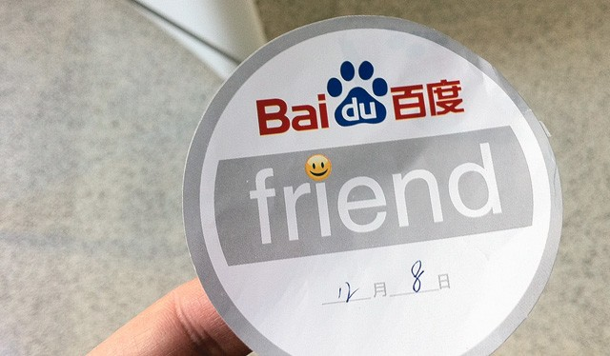

In China, Baidu hosted 62.3% of the country’s searches, ousting Google, which held only 32.8% of searches. Yahoo and Bing tied, each maintaining 2% of searches, according to StatCounter.

Google bounced back to first in China’s mobile search conducting 86.8% of queries. Baidu made a significant drop to 11.3%, and Yahoo inched down to 1.1%.

Google Zeitgeist reveals the Chinese were most interested in global events and politics. Reports show the fastest rising search in the country was for news on the deadly Japanese earthquake, and the fourth highest search term was “Libya.” But the animated movie Kung Fu Panda came in fifth, and “iPad2″ was also a popular search term
in the country as the sixth most searched on Google.com.

United Kingdom

In the UK, search engine uses didn’t fluctuate much — Google held the strongest usage at 92.7%. Bing saw more popularity in the UK countries than elsewhere, hosting 4.6% of searches. On mobile, StatCounter showed Google to be used most at 97.8%, and Yahoo maintained steady use at 1.4%. Ask Jeeves inched up surprisingly with 0.5% of mobile searches on the site.

The royal wedding of Prince William and Kate Middleton was the most popular search in the UK on Google.com. The iPhone was the second most popular, seeing its peak of searches last October when Apple released the iPhone 4S (many thought it would be named the iPhone 5). Celebs Adele and Rebecca Black also made the top
10 list at seventh and ninth, respectively.

Mashable composite: Photos courtesy Flickr, nsikander28, bfishadow.

Series presented by SES

The Future of Search Series is presented by SES Chicago Conference & Expo, leader in education for today’s experience marketing & advertising professionals. From November 12-16, get five days of education, inspiration and conversations with marketing experts across the digital space. Save 20% with the code MASH20.

WRITE A PARAGRAPH BASED ON THE QUESTIONS BELOW.
- Were you surprised by the popularity of any search terms or engines? Why?
- What do you think the popular search terms from each country tell us about what that country is interested in? (Analyze each countries terms individually)
- When you are searching, what engine(s) do you normally use and what terms do you generally search for?

