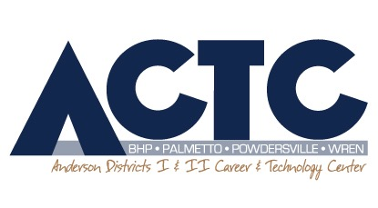

January 6,

Dear Friends,

South Carolina’s only award-winning high school radio station, WPPB The Pulse, is a finalist for 28 national awards at the Intercollegiate Broadcasting System’s 77th Annual National Conference and Awards March 3-5 in New York City.

The conference allows students to attend workshops to learn from media professionals, and to network with other college and high school media colleagues. The awards program will provide the recognition of their accomplishments as a finalist or, perhaps, as a national winner in their categories.

Over 30 Media Broadcasting students, representing Wren, Palmetto, Powdersville and Belton-Honea Path High Schools, have proven to be the best of the best this year by having their radio works qualify for national high school media awards in New York City. We are hoping that most of them will be able to attend, but the cost of the trip is around $600 per person.

We are asking you, as an upstanding and respected business in our community, to please support these young and talented communicators by donating to the ACTC Media Broadcasting program. Every penny will go towards funding the trip for these outstanding students.

After donating, you will receive a letter from ACTC documenting the donation so that you can deduct it from your taxes, so please make all checks payable to ACTC, with a memo to the Media Broadcasting Program. WPPB will also produce a commercial for your business which will run for one year on mypulseradio.com, our free WPPB The Pulse app, and the TuneIn app.
Web advertising, player advertising, and print advertising are also available on all WPPB listening formats and promotional materials. For more details, please visit mypulseradio.com.

In a most-important time in our world to learn and perfect communication skills, the Media Broadcasting program at Anderson Districts 1 & 2 Career and Technology Center provides students with not only the experience and expertise to work in the media industry but also to be a media expert in any industry.

Thank you for supporting these most-deserving students who have the chance to go on this amazing trip to New York City! Please contact me with any questions or concerns at 864.847.4121 ext. 2141. And please come by sometime to tour our facilities!

Sincerely,

John S. Boone
Media Broadcasting Instructor/WPPB The Pulse Adviser
Anderson Districts 1 & 2 Career and Technology Center
702 Belton Hwy
Williamston, SC 29697
jboone@andersonctc.k12.sc.us

