**5 Student Projects That Just Might Transform City Life**

August 29, 2012 by  ***Lauren Drell*** 0



*The Global Innovation Series is presented by BMW i, a new concept dedicated*

*to providing mobility solutions for the urban environment. It delivers more than purpose-built electric vehicles -- it delivers smart mobility services. Visit*

*bmw-i.com or follow @BMWi on Twitter.*

The children are our future, and while they enjoy their fair share of Angry Birds sessions and *Twilight* marathons, they’re a pretty innovative and impressive bunch. Below, we’ve outlined five projects that show the young’uns are in control and will use technology to make the world a better place.

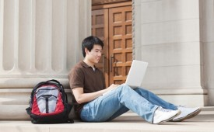

“Showing young people how technology is a tool, and fostering an entrepreneurial spirit toward problem solving, can be incredibly empowering,” explains Terry Howerton, chairman of the Chicago Tech Academy and founder of the incubator

Te chNexus. By starting students on a tech track at a young age, we’re preparing the next generation to think outside the box and create innovative solutions to the world’s problems.

**1. MetroCards for Good**

The MTA collects $52 million a year from unused MetroCards; you’d think with all those funds, New Yorkers could at least get some reliable service. The group of NYU students behind MetroChange.org has a more

altruistic idea — to let commuters donate their unused MetroCard balances to charity. The students are in the university’s Interactive Telecommunications Program, and they’ve developed a kiosk that would let New Yorkers swipe their card to dump the excess money into a central pot that would be distributed to a charity each month (the empty card would then be recycled). Imagine what the philanthropic groups in your city could do with $52 million a year.

**2. German Students Rerouting Traffic**

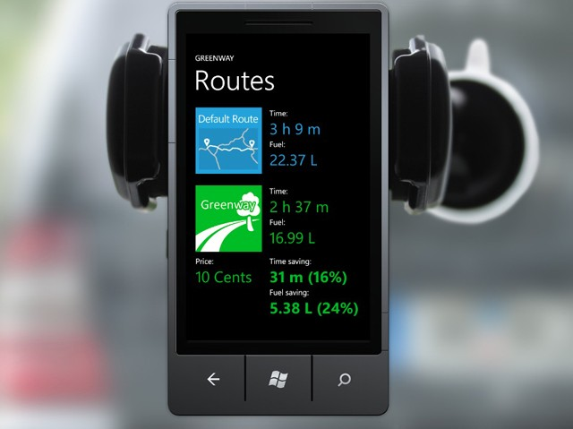

Four years ago, while sitting in a London cafe and observing that some streets are congested while others are empty, a group of German students had an epiphany and founded Greenway.

“We thought of ways to improve traffic flow, and the idea of balancing traffic in an optimal way was born,” says one of the founders, Christian Brüggemann. “The team has a very strong competency in graph theory, and this was a great chance to apply research to a real world problem that we consider very important.”

Greenway is a mobile application and navigation system that calculates the best route for each driver to prevent traffic and reduce CO2 emissions. It’ll save drivers money, fuel, headaches and time — the average person spends 60 hours in traffic each year, says the Greenway team — improvements that are always heralded by city dwellers. Better yet, Greenway optimizes the number of cars to send on each route, so a traffic jam on one boulevard doesn’t just get displaced to another area.

“Life in cities can be very stressful, especially in rush hour traffic,” says Brüggemann. “Greenway can reduce the overall congestion and speed up traffic flow by up to 50%. This will reduce fuel consumption and therefore contribute to a more sustainable environment.”

**SEE ALSO: Get There Faster With These 4 Traffic Apps**

The Greenway team entered Microsoft’s Imagine Cup this year and won the Coca-Cola Environmental

Sustainability Award, which garnered them a $10,000 cash prize. The Greenway team estimates that even if only

10% of drivers in a city use their application, they would have enough information to re-route cars and substantially mitigate traffic jams. The Greenway team is piloting a program in Germany, and its business model enables them to pocket a small percentage of the money a driver saves on gas by taking Greenway’s more efficient routes. Greenway hopes to take an app to market in the near future, and is currently raising seed money. “Our long-term goal is to reach a vast number of users in order to optimize traffic flow as a whole,” says Brüggemann.

**3. Chicago Tech Academy’s High-Tech Algorithm**

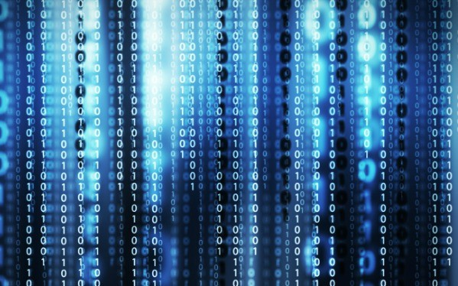

The Chicago Tech Academy is a group of inner-city high school students who take a tech-focused curriculum, from extra periods of math and science to English courses taught by Groupon copywriters, and the program is run with Chicago incubator TechNexus. Since May, a group of 10 students worked with CeaseFire to develop an algorithm for an alert system to promote safety against gun violence in Chicago, a program that would ideally be expanded to all major American cities.

Terry Howerton, who runs TechNexus and chairs the Chicago Tech Academy, says the goal is to crowdsource anonymous tips from the community, then filter and organize the data so it is actionable, whether it’s passed to the police, a community group or a city-wide text alert system. This fall, the students will work on prototypes; a

group in Rhode Island has already reached out about applying the technology in their own community.

The project came about during a typical monthly session where TechNexus hosts students from Chicago Tech Academy s to show them the young tech companies incubating there, and get the students thinking about entrepreneurship and business planning. A May conversation turned to the violence one student had experienced; two hours later, says Howerton, the students had brainstormed a technology solution involving text messaging and a web platform. The idea might help ameliorate the escalating nature of retaliatory violence and help people report intel to the authorities.

“With these students, there is a new sense of empowerment, that they can be part of a solution to a problem they identified,” says Howerton.

**4. Paint-On Solar Cells**

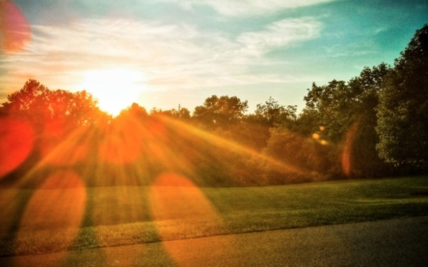

Sixteen-year-olds Allison Martin, Shyamsunder Raghavan and Toluwani Soares invented a paint-on solar cell that harvests energy and can be used on roads, homes, bikes, cars and more, harnessing energy for a more sustainable city. The idea came about when Martin was reading an article that said, *Imagine a world where all of our roadways were replaced with drive-on solar panels*. The students determined that implementing solar panels atop roads would not be “financially plausible,” but they did see promise in a paint-on solar panel.

“This project has the potential to change the face of the energy industry and the face of the Earth,” says Raghavan. “We live in a time when, in order for a product to be successful, it should be, and needs to be, economically efficient. Our paint is, as far as we know, the first paint that can be applied to a non-conductive substrate.”

Raghavan says that before the product goes to market, the team plans to increase the cost efficiency and power

efficiency of the paint.

**5. Search-and-Rescue Robots**

Error getting block information from server.

System.Exception: Exception: System.Exception: Only received 14 of expected 22 bytes. at PolicyServer.PolicyClient.QueryBlockInfo(String blockID, IPAddress clientIP) in c:\Devel\CODE_BASE\TTC\0802xx\Website\Library\PolicyServerClient.cs:line 348

---> System.Exception: Only received 14 of expected 22 bytes. at PolicyServer.PolicyClient.QueryBlockInfo(String blockID, IPAddress clientIP) in c:\Devel\CODE_BASE\TTC\0802xx\Website\Library\PolicyServerClient.cs:line 348 --- End of inner exception stack trace --- at PolicyServer.PolicyClient.QueryBlockInfo(String blockID, IPAddress clientIP) in c:\Devel\CODE_BASE\TTC\0802xx\Website\Library\PolicyServerClient.cs:line 417 at BlockedPageLib.QueryBlockInfo(String blockID)

When a natural disaster strikes, first-responders put themselves in harm’s way and enter the danger zone to look for survivors. But two Slovakian students, Jan Matas and Andrej Oliver Chudy, figured out an alternative — a compact, smart robot that can assess the damage and provide valuable data to the city, keeping humans out of harm’s way. The search-and-rescue device is surprisingly low-cost (around $1,200), and has sensors to detect human heat, which would point rescue crews toward survivors.

What project do you foresee your city using? Tell us in the comments.

*Image courtesy of iStockphoto, YinYang, loops7*

**Series presented by BMW i**

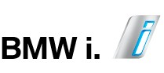

*The Global Innovation Series is presented by BMW i, a new concept dedicated to providing mobility solutions for the urban environment. It delivers more than purpose-built electric vehicles; it delivers smart mobility services within and beyond the car. Visit bmw-i.com or follow @BMWi on Twitter. Are you an innovative entrepreneur? Submit your pitch to BMW i Ventures, a mobility and tech venture capital company.*

Error getting block information from server.

System.Exception: Exception: System.Exception: Only received 14 of expected 22 bytes. at PolicyServer.PolicyClient.QueryBlockInfo(String blockID, IPAddress clientIP) in c:\Devel\CODE_BASE\TTC\0802xx\Website\Library\PolicyServerClient.cs:line 348

---> System.Exception: Only received 14 of expected 22 bytes. at PolicyServer.PolicyClient.QueryBlockInfo(String blockID, IPAddress clientIP) in c:\Devel\CODE_BASE\TTC\0802xx\Website\Library\PolicyServerClient.cs:line 348 --- End of inner exception stack trace --- at PolicyServer.PolicyClient.QueryBlockInfo(String blockID, IPAddress clientIP) in c:\Devel\CODE_BASE\TTC\0802xx\Website\Library\PolicyServerClient.cs:line 417 at BlockedPageLib.QueryBlockInfo(String blockID)